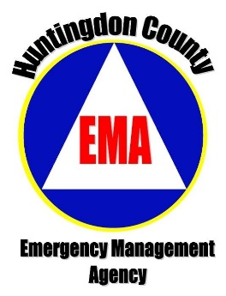 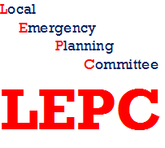

**Annual**

**Business and Emergency Services**

**Training Summit**

When: Friday, September 14, 2018

Location: Mount Union Fire Hall, 15 East Market St., Mount Union

Time: 8:30 a.m. Registration with coffee and donuts

9:00 a.m. Presentations begin

**9:00 a.m. PEMA/EMA/LEPC: “Get to Know Us”**- Emergency management has a long history in Pennsylvania and Huntingdon County. Allow us to introduce ourselves; who we are, what we do, how we can be of service to you, your business, your emergency service and the community.

**10:00 a.m. Pennsylvania State Police: “Active Assailant Awareness”**- The likelihood of an active assailant situation is now recognized by the US Government (OSHA, FBI, Homeland Security) to be an event that is “More Likely Than Not” to occur. We’ll help you prepare for the possibility as thoroughly as possible by outlining the basics of a situation any of us could face at anytime, anywhere.

**11:00 a.m. National Weather Service: Be “Weather Ready Huntingdon County”**- Learn about business and emergency services weather challenges, solutions, and forecast information available to you. Maybe the NWS will even share predictions for the winter season in our area!

**12:00 noon- Lunch**: Provided by Huntingdon County Business and Industry

**1:00 p.m. - Business and Agriculture Hazardous Materials Transportation Emergencies Awareness”**- In our area we have businesses and agriculture operations using and transporting hazardous materials meaning a variety of emergencies and disasters can occur. What are the most common chemicals used in or transported through Huntingdon County? What resources should be requested in case of emergencies? This 2 ½ hour class will provide the details and answers!

Summit preregistration is required by Wednesday, September 12th through the EMA Office in the Courthouse; Phone 643-6613; Email: [emaregistration@huntingdoncounty.net](mailto:emaregistration@huntingdoncounty.net)

Certificates of attendance will be available for all trainings.

The Annual Training Summit is hosted by Huntingdon County Emergency Management Agency (EMA), Huntingdon County Local Emergency Planning Committee (LEPC) and Huntingdon County Business and Industry (HCB&I).